Word-ware link - <https://app.wordware.ai/explore/apps/c502ec70-fd94-488d-b679-7c4b0186e95a>

Input   
  
user_query: Suggest me a best plan

Age: 27

Family type: Individual

Family Count: 1

Special requirement: Looking for dental plans

Response

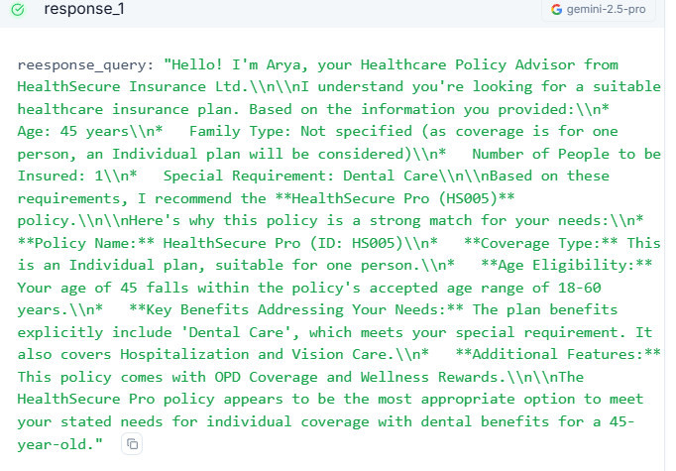

Change to family plan

